Walk 24 Burghill and Tillington
Last walked in October 2017

Description. A 9 km (5.6 mile) walk, mostly bridle paths and country lanes. Three stiles. Sites ancient and modern. Hereford Times September 2012.
Start. Explorer Map 202 Grid 479445.
Direction from Whitecross (Turn milometer to zero). Take the A4110 Canon Pyon (Three Elms road) for 1 mile and TL at the lights. Point 2 of a mile further on you TR and go along Tillington Road for Burghill 1½. At 2.2 miles you branch R for Burghill. At 2.8 miles TL for the church car park.

1. St Mary’s Church, Burghill. (Among the antiquities in the church are a curious font of metal, placed on a stone figuratively carved of the Twelve Apostles; and a very richly carved oak screen, one of the finest in England). With the church behind you and to the R, TL and proceed up the enclosed wide bridle path/drive heading towards the mast that’s in front, at the top of the hill. Go past a house on your L and continue on up the enclosed grass/dirt track. When you get near the top you will pass the radio mast that’s in a field on your R hand side, then you pass a bungalow on your L and start to descend. At the slight R bend (the road can be seen below), TL thru a gate gap and by a signed bridle path into F1.

2. Go thru bridle gate. Continue up the L edge of the field to go thru a small wooden gate into F2. Ignore the way marker and go diagonally R, across and down the field to the bottom far corner, to go thru a way marked small wooden gate into F3, (if the field is heavily cropped then TR and follow R edge of the field down and around). Cut straight across this field, (if field is heavily cropped you go up and around the L edge), to go thru a small wooden gate that’s about 80m down from the top of the field, into an enclosure. Continue across the top edge of the enclosure and pass some Mountain board Slopes that are on your L. Go out thru a gateway onto a wide enclosed drive and TL, towards Farm Shop and PYO. Ignore the Farm Shop as you go ahead thru Tillington Court buildings to follow a more surfaced drive at CourtCottage. Continue along the surfaced drive to reach a narrow country road T-junction and TL. Continue along this road to reach cross-roads that are by a pond on your L, and opposite Tillington Business Park.

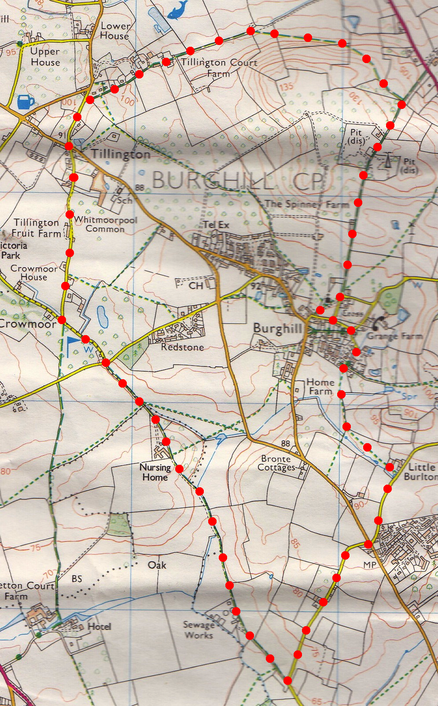
3. Tillington pool. Go (carefully) straight across the cross-road and continue along the narrow country road opposite. Continue along the road for almost a km, going past Tillington Fruit Farm, to reach a T-junction, a gap into a golf course is ahead. TL, and continue to the end of the narrow country road (Crowmoor Lane), to reach a cross roads. Go straight across and up the lane/drive ahead that goes to Stretton Nursing Home. At the gated driveway, (gate no longer there) keep to the L hand side and go up the grassy ride between trees and hedge, keeping to the L hand side of the home. When you reach the upper end of the Home you go straight on ahead, thru a metal gate and into F4, ignore the small wooden kissing gate on the L. Continue on down the L edge, down a wide, grassy path. Go thru a metal gate and along an enclosed grassy path to reach the end, (about 130m), to go thru a small wooden gate on your L, into F5 and continue in the same direction. After a short distance (20 paces), the field edge turns R and you continue straight ahead, walking along a wide grassy track, initially you go between a crop (on the L) and tree plantation (on the R), to reach a metal gate. Go thru the gate and along an enclosed farm track. The track turns into a tarmac lane, to go thru a metal gate and onto a T-junction at a bend in a minor country road
2
3

4. Tow Tree Lane. TL. The country road goes slightly upwards for about ¾ of a km. Pass Tow Tree House (R) and reach the Hereford to Burghill road. (Cross to the pavement that’s by 27 Willow House and TR, walk on for 115m. TL into St Mary’s Lane 175m to Chestnut Lane. TR to memorial tablet unveiled on August 18, 2011, the 67th anniversary of the crash in which 10 United States servicemen and flying crew lost their lives. Return to crossroads at 27 Willow House and TR.) Cross over the main road and continue on down the road opposite, to reach a pool (L). TL, and walk along a pebble path at Little Burlton, to cross a stile into a field. Go straight ahead and at the end of this field, in the far R corner, you cross over a stile into another field. Keep to the R edge of the cropped field as it bends R, then bends L. Continue on to go thru a kissing gate that’s in the R corner. Go ahead along surfaced lane to Lower Orchards T junction. TL and walk up to the next T-junction. TL and 100m along this road you TR and go up to the car park. (“Twelve Apostles”. Go up churchyard between Yew trees. Plaque to airmen is by Memorial Cross. TR to exit just above “Wordsworth’s” ancient yew. Plaque to St Mary’s dead is in northern churchyard.)
1

4

